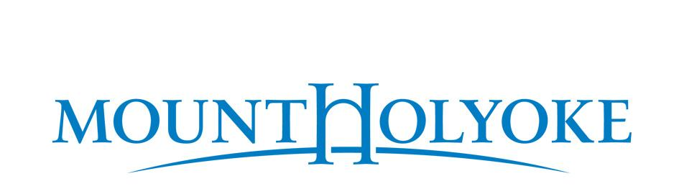
50 College St., South Hadley, MA 01075-1459

FOR IMMEDIATE RELEASE:
Contact: Christian Feuerstein
Director of Media and Public Affairs
413-538-2793 | Email: cfeuerst@mtholyoke.edu

DATE

STUDENT NAME of CITY/TOWN graduates from Mount Holyoke College

SOUTH HADLEY, Mass.—NAME graduated with a DEGREE/HONORS at the 189th Commencement ceremony at Mount Holyoke College on Sunday, May 24, 2026.

While at Mount Holyoke, LAST NAME majored in SUBJECT/ SUBJECTS and (IF APPLICABLE) was (CHOOSE ONE) honored with OR received (AWARDS/FELLOWSHIPS/DISTINCTIONS and brief description) OR participated in (NAME OF CLUBS AND ORGANIZATIONS). [Optional: LAST NAME is the child of PARENTS’ NAMES AND HOMETOWNS.]

—##—

ABOUT MOUNT HOLYOKE COLLEGE
Mount Holyoke College empowers students to learn beyond boundaries and make change for all. Engaging with our interdisciplinary curriculum, experiential learning opportunities and authentically bold culture, students break with convention to open new possibilities for their futures, communities and the world. A women's college that is gender diverse, Mount Holyoke's vibrant campus and global community in South Hadley, Massachusetts is home to 2200 students. Together, we build on over 180 years of trailblazing tradition to move us all forward. To learn more, visit mtholyoke.edu.

Example:

FOR IMMEDIATE RELEASE:
Contact: Christian Feuerstein
Director of Media and Public Affairs
413-538-2793 | Email: cfeuerst@mtholyoke.edu

May 26, 2025

Jane Doe of Smalltown graduates from Mount Holyoke College

SOUTH HADLEY, Mass.—Jane Doe graduated summa cum laude with a bachelor of arts degree at the 188th Commencement ceremony at Mount Holyoke College on Sunday, May 25, 2025.

While at Mount Holyoke, Doe majored in International Relations with a minor in French studies and received a Fulbright fellowship to continue her study as a graduate student at Oxford University in England. She was also a hall senator for the Student Government Association. Doe is the child of John and Mary Doe, also of Smalltown.

—##—

ABOUT MOUNT HOLYOKE COLLEGE
Mount Holyoke College empowers students to learn beyond boundaries and make change for all. Engaging with our interdisciplinary curriculum, experiential learning opportunities and authentically bold culture, students break with convention to open new possibilities for their futures, communities and the world. A women's college that is gender diverse, Mount Holyoke's vibrant campus and global community in South Hadley, Massachusetts is home to 2200 students. Together, we build on over 180 years of trailblazing tradition to move us all forward. To learn more, visit mtholyoke.edu.

